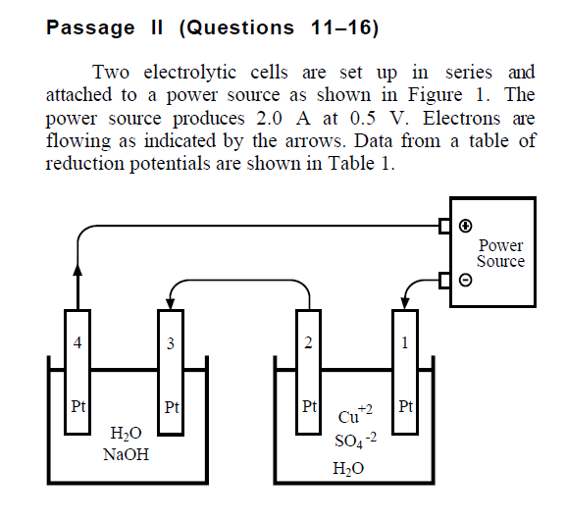

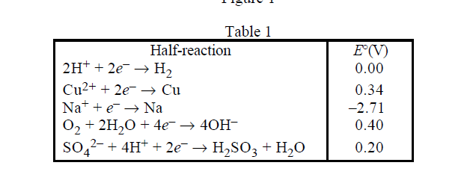

1 2 . At which electrode is oxygen gas liberated?
A . 4 only
B . 1 and 2 only
C . 2 and 4 only
D . 2, 3, and 4 only



