Orgo Notes

Notes:
edg increase base/nucleophile
ewg increase acid/electrophile
pKa for a H coming off Carbonyl VERY ACIDIC
long crystals indicate high purity since impurities inhibit growth |  |  | **
in crystallization, we want a low affinity of the solvent to the lattice
Lab info: 1) crystallization: most important method for purifaction
2) Gas Chromo. Used to separate volatile mixtures i.e alkenes/alcohols
3) Azeotrope: constant boiling mixture that distillation cannot separate
4) TLC: Separating Non volatile mixtures
5) Steam distillation: distills at a temp below low boiling component
used to isolate oils, waxes, fats (immiscible liquids)
Fructose- enediol intermediate when put in base; extract H from c2 (when going Glu to Fructose)
first 4 alkanes are gases
 |  |  | **
lowest heat of combustion: most branched (most stable!!) |  |  | **
Dieckmann Condensation: similar to claien condensation, forms 5-6
membered cyclic beta keto esters
Heck rxn: combines aryl and vinyl halides
Most acidic hydrogen #41/42- phenol/ acid have high pka
protonated cationic H> acid> phenol (see bookmarked chart)
Protonated cationic H>acid>diketone>phenol
halogen acids extremely stronger than all (h2so4 strongest) |  |  | **
br2/ccl4 and cold dilute kmno4 gives positive test on alkanes/alkynes
UV spec: conjugation- examines transitions between electronic energy levels
this means that when hit with uV light, promoted up energy level
mass spec: moelcule bombarded with high energy electrons (forms radical cation)
sn2 transition state: nuclephile and leaving group attached to same carbon.
leaving group, like Iodine, will have a neg charge |  |  | **
if nucleophile has 3-4 bonds to transition state, it has a posiitve charge
methoxy attacking would have a negative transition state, methanol positive (see textbook)
double dehydrohalogenation is an E2 mechanism |  |  | **
 |  |  | **
amide has resonance (double bond locks the peptide)
diels alderis a concerted reactions----one step! |  |  | **
aldehydes and ketones DO NOTTT go under nuc acyl sub
Excess D2O w/ catalytic DCl is like an alpha additon of br2/oh (add multiple D) |  |  | **
DEXTRO (+) LEVO (-); NOTHING TO DO WITH R/S
ex: if a compound is R, you cant tell if if it is dextro/levo (+/-)
aldehydic and vinyllic protons are weak. Alpha protons on an aldehyde
are more acidic than the aldehydic proton |  |  | **
for malonic/acetoacetic ester, whether youre adding 1/2 groups, the ester |  |  | **
component comes off. Malonic will have a carbocyllyc acid end
the other will have a methyl end
alcohol dehydration reactivity: 3>2>1. E1 for 3,2 and E2 for 1 |  |  | 258,260
small rings like cyclopropane/butane will give alkanes with catalytic hydrogen
 |  |  | **
sn2 Reaction: 100% inversion, conc of halide and nuc needed, backside attack.
in transiiton state, carbon goes from being sp3 (must be sp3) to sp2 then
back to sp3; strong solvents (DMSO), strong nuc
 | Look over diels alder |  | **
highly polar solvents have high dielectric constants. If constant >15, it is polar
propogation steps of fluorine are highly exothermic, while in Iodine, endothermic
halogen reactivity for radicals: F>Cl>Br>I (higher reactivity, more exothermic)
conjugation lowers frequency. Frequency increses with stronger bonds, and decreases when atomic mass inc
conjugation increases wavelength
shortest bonds have more sp2/sp. If resonance is involved, then they are not "true" double bonds
sn1 slow step: formation of carbocation
dna: bases inside helix, sugar phosphate outside
if solvent is not known, nucleophilicity increases right to left, and down a group
Nuc trend: charge, electronegatvity (opp), solvent, steric hinderance
amines larger than 3 C are not water soluble
thermodynamic (40 degrees- 1,4 addition)
kinetic: -40: 1,2 additon
protected carbonyl is an o-p director
when doing elimination on a cyclohexane, draw chair conformation
never use LiAlH4 with JUST water. Use ether followed by H+ (or water)
also catalytic hydrog works here too
isobutyl group is an isopropyl with an extra ch2
the only reversible benzene rxn is sulfonation
sugars: if hemiacetal is present: can mutorotate, open up to free chain form,
which is an aldehyde, gives a positive tollens/benedict test, and is a reducing sugar
ex: sucrose has no hemiacetal component. Hence, it has no free OH to mutorotate,
open up to aldehyde chain, and gives a negative for above tests
glyceraldehyde is a reducing sugar; glycosidic link= acetal link
terminal alkyne and grignard: switches terminal H for grignad component (MgBr/Cl)
smaller heat of hydrogenation means more stable alkene
alkenes react with ch2n2 to form a cyclopropane component
polyurethanes formed from diisocyannates and diols
LDA or n-butlylithium removes the most acidic proton
the more conjugated, the more stable
sn1/E1 share same rate law and the same carbocation, k (substrate or halide)
E2/sn2 siff rate laws; base/nucleophile
sn1/e1 both have 2 steps
ionizable R group AA: tyrosine and Cysteine
grignards react with acidic hydrogens or electrophillic double bonds (doesn’t give the typical product if present)
alcohols/ethers formula: C(x)H2x+2O
Alc*KOH, heat does alcohol dehydrog, or regular elimination (E2), while aqueous koh gives substitution
small heats of combustion mean more stable
meso compounds have a rotation of 0
E2 on a primary halide requires bulky base, and gives less substituted
(plus, it can only give the Hoffman product anyhow..)
wiliamson: sn2, so primary, secondary,
all aromatic compounds, not just benzene, can go under EAS
fractional dist. Good if 2 compounds close to each other in BP. Centrifigution good for RBC; more dense go to bottom.
Sand and charcoal are insoluble so they wont affect the BP
general acidity trend:aromatic acids, carboxy acids, alcohols, ketones/aldehydes, alkynes, alkenes, alkanes
filtration should be used first, or in general to get rid of insoluble impurities, like sand
evaporation can get ride of ether (same as boiling off)
don’t want a EWG on a Carbon with a pos charge (unstable!)
o/p very stable when EDG forms double bond on ring
o/p very UNSTABLE when EWG is on a positive carbon (pg 763-766)
for o/p with a donating group that cannot give up free electrons, like ch3,
most stable form is when the r group is on the same C as the positive charge, adds stability
problems 256, 258, 260
more double bonds: inc fluidity, dec MP (unsaturated/ unsaturated)
sn2 Reaction: 100% inversion, conc of halide and nuc needed, backside attack.
in transiiton state, carbon goes from being sp3 (must be sp3) to sp2 then
back to sp3; strong solvents (DMSO), strong nuc
pentacoordinate transition state
if an R molecule reacts, the pentacoordinate transition state is partially S,
since its starting to go thru inversion
sp2 transition state b/c leaving group/ attacking group not fully bound
Dicarboxyllic acid and heat from cyclic anhydrides (count carbons)
when doing 2^n for number of stereoisomers, consider meso.
ex: 2,4 dichloropentane. Has 2 sterocenters, but forms 3 products since 1 is meso (b/c duplicate meso)
nanh2 w/ or w/o nh3 removes alkyne H. Gringard on a terminal alkyne switches
the MgBr component of the grignard with the alkyne H, and transfers the H to the other compound
ex: H-CEEEEC-CH3 w/ CH3MGBr gives MgBr-CEEEEC-CH3 +CH4
imines are addition elimination reactions
epimers are diastereomers which differ at 1 carbon only (sugars)
aldol condensation intermediate is enolate with two resonance forms
terpene: isoprene unit
bonds in benene are in between single and double
alcohols/ethers isomeric for same carbon numbers
aldehydes and ketones isomeric for same carbon numbers
check for aromaticity when determining strongest acid
aromaticity weakens/stabilizes base
for alkene stereoisomers/number of products, consider E/Z if possible

Jones reagent oxidizes

Groups like –OR and CN are poor leaving groups- no substitution

LDA will remove the proton selectively from the carbon substituted with the fewest number of carbons: (also will remove most acidic hydrogen when applicable)

Hydrolysis of cyclic ester makes carboxy end and alcohol end

Tollens test gives positive for ald or alpha hydroxy ketone. 2,4 dnp gives positive for carbonyl

Anthracene has 3 rings; naphthalene has 2

Acetal/hemiacetal works for ketones/aldehydes
For E2, leaving group and H must be coaxial

Aldehyde oxidizes to acid in air

When using LiAlH4, use ether, then H20 or H+---not just water!!! (amide, nitrile) or use catalytic hydrogenation

Allenes are an ex of cumulated dienes

General acidity trend: aromatic acid, carboxy acid, alcohol, ketone, aldehyde, alkyne, alkene, alkanes

Bayern villiger: add o to more substituted side. If aldehyde, add to the H side

For diels alder, groups with pi bonds are in endo position (down)

Least acidic of below: C (use CARDIO)

Which of the following is the LEAST acidic?
- A. 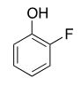
- B. 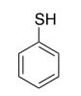
- C. 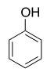
- D. 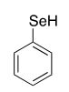
- E. 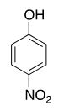

t

Trans isomer more stable (less steric strain)

If a compound has two different sets of alpha hydrogen or both reactants have alpha-hydrogen, the reaction will produce a mixture of products (aldol condensation)

Beta decarboxylation always involves heat, and may include H+

when determining hybridization, count the number of attached atoms and lone PAIRS. This means that an unpaired radical electron will not be counted.

Volatile compounds will best be separated by a method that involves the gas phase.

Intermolecular forces will determine relative melting point. The stronger the intermolecular forces, the higher the melting point. (when checking mp/bp look at IMF, THEN branching)

Imine/ enamine hydrolysis gives the respective ketone/aldehyde

Rank the following in terms of bond length, from LONGEST to SHORTEST.
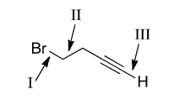
1>2>3 Bond length is related to atom size (atomic radius) and effective orbital overlap. The bigger the atom, the longer the bond, so bondI between carbon and bromine (the largest atom in the molecule) will be the longest. (Br-C bond is bigger than C-C bond)

The proton from OH comes off before NH2

The following conformation has been proposed to be associated with the E2 reaction of compound I with potassiumtert-butoxide. Which of the statements below BEST describes this structure?

- 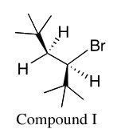 A. The most stable antiperiplanar conformation that leads to the formation of the major product
- B. The least stable antiperiplanar conformation that leads to the formation of the major product
- C. The most stable antiperiplanar conformation that leads to the formation of the minor product
- D. The least stable antiperiplanar conformation that leads to the formation of the minor product (draw the structure when looking at it from the front. The two t-butyl groups will point in the same direction, so cis is the product. Cis is less stable than trans, especially with bulky groups. Also, most stable leads to major product, and least stable leads to minor product)
Which of the following would be the MOST effective means of obtaining pure crystals of D-glucose from a hot solution of ethanol?
- A. Remove the ethanol under reduced pressure (NO! this means you evaporate the ethanol, which would leave glucose with the other molecules, thus leaving it impure)
- B. Gradually cool the solution (you want soluble at high T, insoluble at low T…slowly cool!)
- C. Dilute the solution with warm ethanol (this would re-dissolve glucose)
- D. Add 0.1M aqueous NaOH (not applicable)
- E. Add 0.1M aqueous HCl (not applicable)
Correct
Crystallization involves dissolving a solid in a solution of hot or warm solvent. In order for crystals to properly form, the solution must be cooled gradually. This allows for proper nucleation and crystal growth. As the solution cools, the K_{sp} decreases and the solution becomes supersaturated. The more gradual the cooling process, the better the crystal formation. Removing the ethanol under reduced pressure would produce solid D-glucose, but it would not yield crystals. Therefore, answer choice A can be eliminated. Adding more solvent (answer choices C, D & E) will simply increase the solubility and not lead to any crystallization or precipitation.

Which of the following alkenes produces a meso dichloride when reacted with Cl₂/CCl₄ at room temperature?
- A. 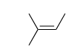
- B. 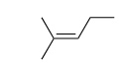D is the answer- draw each out, with wedges for front carbons, and dashes for back carbons. The requirements for meso (via rotation) are opposite configuration at both stereocenters, and same groups; not possible for A/B because there is only 1 stereocenter!
- C. 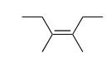
- D. 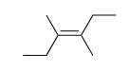
- E. 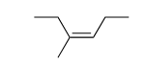

Alcohols react with acids b/c alcohols behave as bronsted lowry bases
Volatile: use gas chromatography or distillation
Nonvolatile: use TLC

Which of the following statements best describes the equilibrium below?
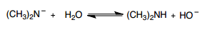
- A. The equilibrium favors the reactants because (CH₃)₂N– has a lower pK_{B} than OH–.
- B. The equilibrium favors the reactants because H₂O has a lower pK_{A} than (CH₃)₂NH.
- C. The equilibrium favors the products because (CH₃)₂NH has a higher pK_{A} than H₂O.
- D. The equilibrium favors the products because (CH₃)₂N– has a higher pK_{B} than OH–.
- E. The equilibrium favors the reactants because (CH₃)₂NH has a lower pK_{A} than H₂O.
Incorrect
This requires knowledge of base strength. Amines are some of the strongest bases you will encounter in organic chemistry. We know that dimethylamine ((CH₃)₂N–) is a stronger base than hydroxide (OH–). The methyl groups are pushing even more electron density onto the negative nitrogen, making this very unstable and highly basic. This means that the products will be greatly favored, eliminating answer choices [A], [B], & [E]. Next, if dimethylamine is a STRONGER base than hydroxide, it will have a LOWER pK_{B}, eliminating choice [D]. Finally, if dimethylamine is a stronger base, it will have a weaker conjugate acid. The weaker the acid, the higher the pK_{A}. This makes statement [C] the only logical explanation.

An unknown compound with molecular formula C₇H₈O displays the following NMR spectral data. Which molecule best matches this information?
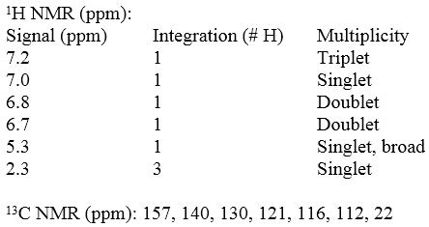
- A. 2-methylphenol
- B. 3-methylphenol
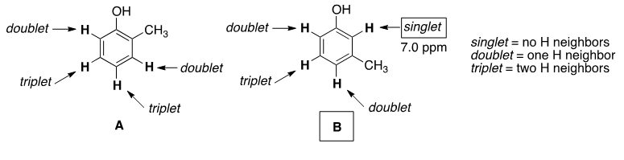
- C. 4-methylphenol
- D. 1-methoxy-3-methylbenzene
- E. methoxybenzene
Correct
Compound D has a molecular formula of C₈H₁₀O. A broad singlet at 5.3 ppm in the ¹H NMR spectrum is indicative of an alcohol (phenol) functional group. A dead giveaway is the presence of a singlet at 7.0 ppm, indicative of an aromatic proton with no neighboring H atoms. ¹³C NMR indicates the presence of seven unique carbon signals, six of which fall into the aromatic region (157–112); therefore, no symmetry is present.

Elimination of Br with NaOCH₃ from which of the following compounds will give (Z)-3-methyl-2-pentene as the major product?
- A. 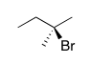
- B. 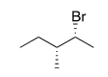
- C. 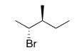Answer is C: view from the side via newmann projection. Carefully place all groups in proper spot or else it doesn’t work
- D. 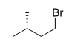
- E. 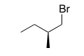

Which of the molecule pairs shown have an enantiomeric relationship?
- A. 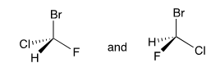
- B. 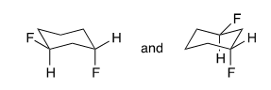B
- C. 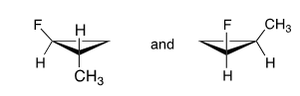
- D. 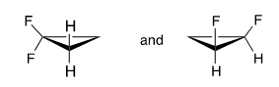
- E. 

