STEP-BY-STEP PROCESS TO GETTING BACK INTO ISU VET SCHOOL
- ☐ BECOME A STUDENT AT ISU – Here is the email that my undergrad advisor John sent me. I am in the process of doing this right now. Keep in mind; I graduated from ISU with a B.S. in Animal Ecology so your situation may be slightly different from mine but this may be a good idea of how to get into ISU undergrad to take classes:
Dear Lindsay,
They are correct, in order to take classes, you have to be listed in some capacity as a student. You could sign up as a returning student and list Animal Science as your new major – even if it is only for one semester. If you do that, you will get assigned an advisor in Animal Science. That probably makes the most sense as it covers the “degree seeking” part of the financial aid question. If you want this, start by calling the Registrar’s Office (515-294-1840) and telling them you want to come back and when. They will issue a RAN for fall that you would then get from your advisor.
Alternatively, you could sign up as a Forestry major, and I could be your advisor, but that would look funny on your transcript. Even if you sign up for Animal Science, we can still work together when you have questions. I just could not be the one signing official documents, etc. for you.
The other possibility that was mentioned it to be a CALS special student. That is the worst of these three alternatives in my view. Special students get the last registration start dates. If you are only taking one semester’s worth of courses that might not be as bad. You would get an advisor in the college office – probably Dr. Tyler.
Becoming a grad student would involve a lot of extra work – and take a lot of time. Again, if you are only planning to take one or two courses to help your academic foundation, I would not recommend this option.
I hope this helps! If you have additional questions, let me know.
- ☐ ENROLL IN AN ISU CLASS – technically the Consortium agreement says to take at least ONE credit at ISU in order for the agreement to be active.
  - Contact Registrar’s Office and explain your situation (i.e. dismissed > curriculum change from vet med to animal science)
  - Contact Mary Lents (515-294-3161) to find out who your Animal Science advisor is
  - Contact your advisor to get your RAN number so you can register for classes
- ☐ ENROLL IN CSU/OSU/ETC. CLASS – the “host” college needs to see that you are enrolled at ISU in order to sign the Consortium agreement
  - When taking CSU/OSU/ETC. classes, you need to enroll in classes that you received a C- or lower in (in vet med). For example, I got a D+ in histo and a D in Nutrition in the fall. Therefore, I will enroll in histo at CSU (BMS 300) and nutrition through OSU (ANSI 3543E) for this coming fall.
  - CSU’s courses for credit: https://www.online.colostate.edu/dotCMS/addToCart
  - OSU’s Nutrition course for 3 credits: http://is.okstate.edu/CourseInfo.vbhtml?section_id=575&fbclid=IwAR0j0JMHNPedi_djDrglTNHoYUdfVWHRXyGR3xFchbgDWTacV0icHc2jKGs
    - NOTE: OSU’S Nutrition course will NOT be covered by ISU’s financial aid sadly, this is an out of pocket expense…
  - Repeat this process for spring semester.
- ☐ FILL OUT CONSORTIUM AGREEMENT FORM – this is pretty straight forward to fill out. The “host” college is the college you will be taking your makeup classes at.
  - Link for ISU’s Consortium Agreement: https://www.financialaid.iastate.edu/consortium-agreement/
  - In order to receive financial aid using the consortium agreement, you need to be a degree-seeking student taking a MINIMUM of 6 credits
    - So for fall I took:
ISU – VDPAM 365 (animal welfare judging) | 1 credit
ISU – ANS 411 (issues in animal science) | 1 credit
CSU – BMS 300 (principles in human physiology) | 4 credits
OSU – ANSI 3543E (animal nutrition) | 3 credits but does NOT count towards financial aid

In the image below, these are the steps of the Consortium Agreement...in simplest terms:
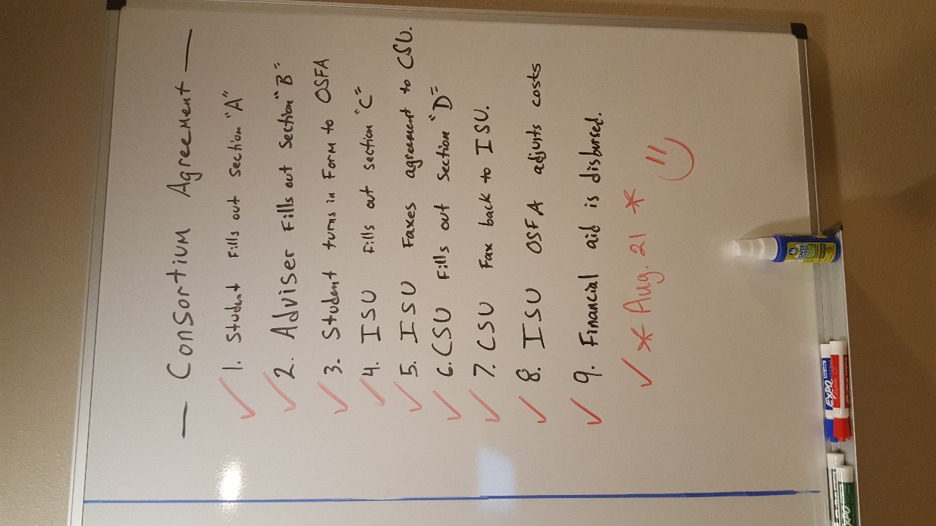

Here is the financial aid award I received for fall and spring semesters
***Remember*** Depending on your situation, your aid award may be slightly different:
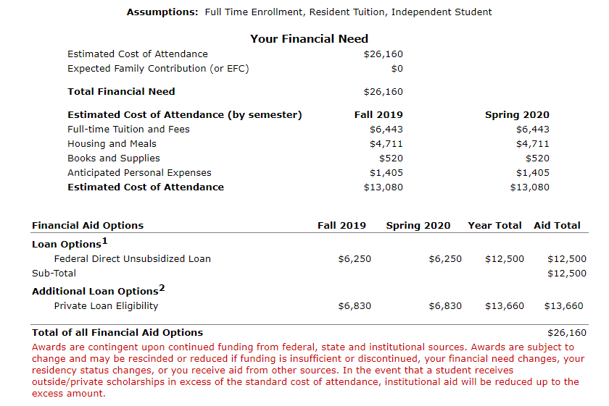

- ☐ DURING DOWN TIME/WAITING TO HEAR BACK FROM PLACES: WORK ON LETTER OF PETITION FOR READMISSION – start your draft early and have many sets of eyes look at it so you can perfect your letter.
- If you need to retake immunology like MOST of us, I would recommend taking Immuno during the summer when you’re not taking on a huge load (i.e. fall or spring semester).
So far, these area all the steps that I’m aware of. If I am missing anything, please feel free to add it to this list and let me know

HANG IN THERE!!! YOU CAN DO THIS!!! They’re making this difficult because they’re testing us! You DESERVE to be a veterinarian!!!!!! Don’t get discouraged!!! <3 <3 <3

